*Solution for Assignment 2:*

COMP-352

by

Shadi Jiha (40131284)

Concordia University

Department of Computer Science and Software engineering

04 June 2021

**Question 1:**

* 1. The big-O of this algorithm is $O(n^{2})$ because the major part of the algorithm (from line 4 to 12) contains 2 nested loops which, each of them has $n$ iteration in worst case.
  2. The big-Omega is $Ω(n^{2})$ because the major part of the algorithm (from 4 line to 12) contains 2 nested where at best the $if$ statement is skipped. However, even if the $if$ statement if skipped, the double for loops still have to run.

1. Here is the result of the algorithm:

Input: {60, 35, 81, 98, 14, 47}

Output: {14, 35, 47, 60, 81, 98}

|  |  |  |  |
| --- | --- | --- | --- |
| Line | Array A | Array Var | Array S |
| After line 3 | [60, 35, 81, 98, 14, 47] | [0, 0, 0, 0, 0, 0] | [0, 0, 0, 0, 0, 0] |
| After line 12 | [60, 35, 81, 98, 14, 47] | [3, 1, 4, 5, 0, 2] | [0, 0, 0, 0, 0, 0] |
| After line 15 | [60, 35, 81, 98, 14, 47] | [3, 1, 4, 5, 0, 2] | [14, 35, 47, 60, 81, 98] |

1. The algorithm is sorting the array in ascending order. The values in the Var array are the order of elements A in the array S. For example, if the input is array [10, 9, 1, 2, 4, 8], then the array S will be [1, 2, 4, 8, 9, 10] and the Var array is [5, 4, 0, 1, 2, 3].
2. Yes, it possible, we can use the heap-sort algorithm which has a $O\left(n∙\log\left(n\right)\right)$ and $Ω(n∙\log{(n)})$:
3. The space complexity of this algorithm is $f\left(n\right)=3n$ or $O(n)$. Because we need 3 arrays each of them of size n. It can be improved by swapping elements directly in the array instead of creating new ones.

**Algorithm** DoSomething(A, n)

**Input:** Array A of size n

**Output**: Sorted Array A

**for** i ← n / 2 - 1 **to** i >← 0 **do**

heapify(A, n, i)

**for** i ← n - 1 **to** i > 0 **do**

temp ← A[0]

A[0] ← A[i]

A[i] ← A[0]

heapify(A, i, 0)

**Algorithm** heapify(array, n, i)

**Input:** array of size n, i is the node index to sort

**Output**: a sorted branch of tree array of node i

max ← i

l ← 2 * i + 1

r ← 2 * i + 2

**if** l < n **and** array[l] > array[max] **then**

max ← l

**if** r < n **and** array[r] > array[max] **then**

max ← r

**if** max != i **then**

swap ← array[i]

array[i] ← array[max]

array[max] ← swap

heapify(array, n, max)

**Question 2:**

1. Category 1: List, because the operations for *lookup*, *set* are O(1).
2. Category 2: Positional, because containers need to be eliminated or added in particular position before or after a certain container relative to the start position of the array.
3. Category 3: Sequence because the *add* and *remove* must be done in a sorted array.

**Question 3:**

1. To get both orders we need to construct to following tree:

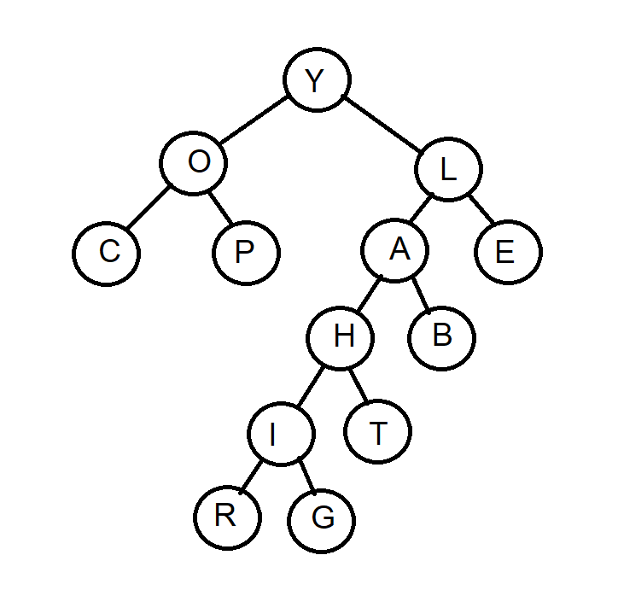

1. The array that will store this binary tree is (All empty spaces are null elements):

|  |  |
| --- | --- |
| Y|O|L|C|P|A|E| | | | |H|B| | | | | | | | | | |I|T| | | | | | | | | | | | | | |
| | | | |R|G| | | | | | | | | | | | | | | | | |  |

**Question 4:**

1. This is the insertion step by step:

2. Insert 13

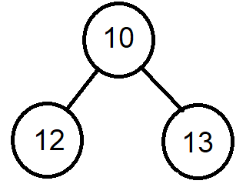

1. Insert 10 then 12:

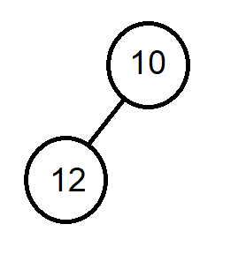

5. Insert 16

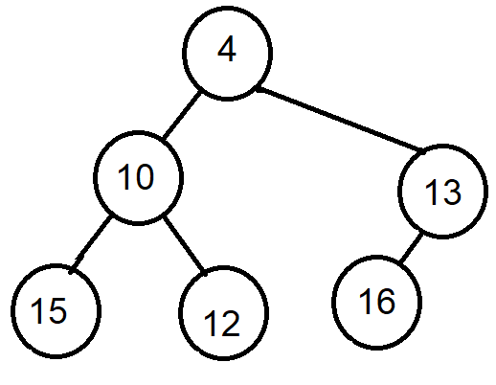

4. Insert 4

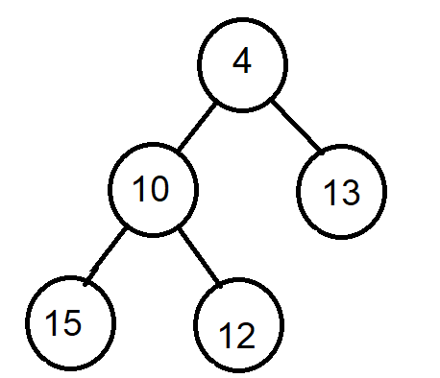

3. Insert 15

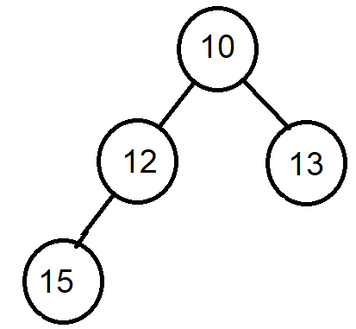

7. Insert 9

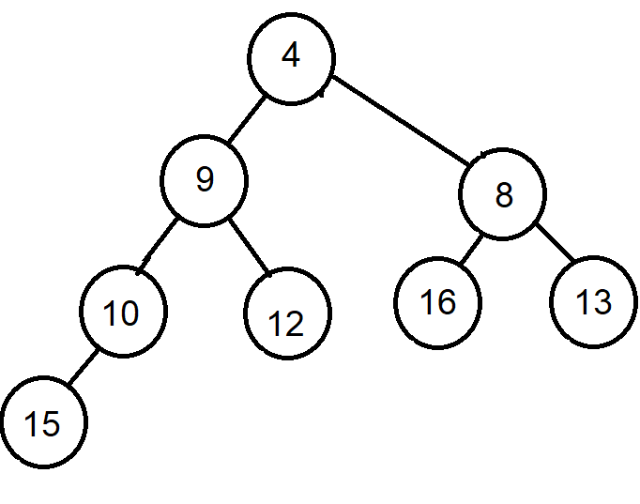

6. Insert 8

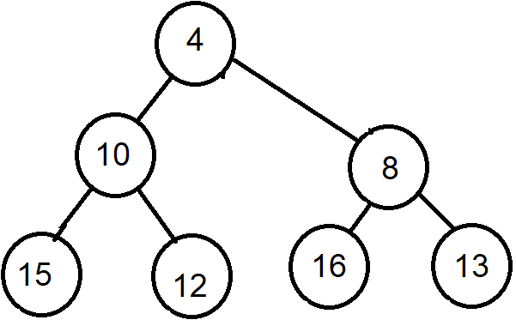

12. Insert 6

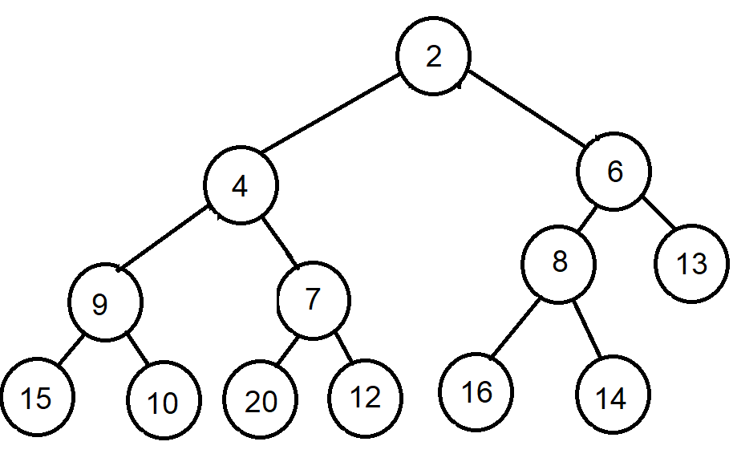

11. Insert 14

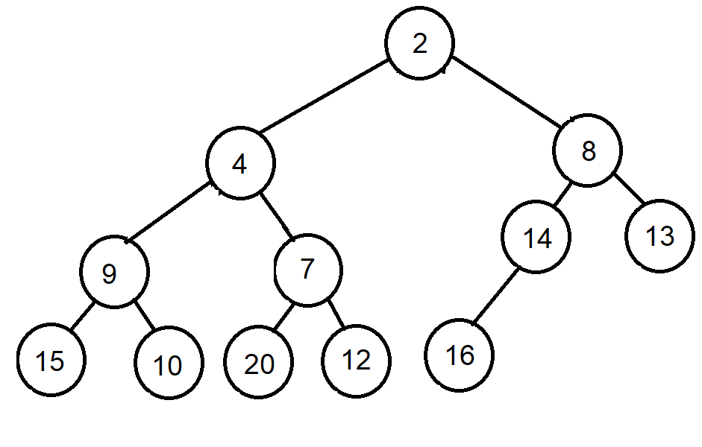

10. Insert 7

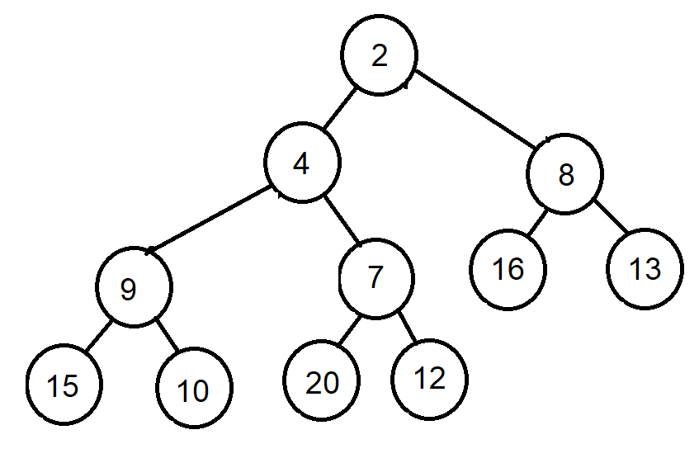

9. Insert 20

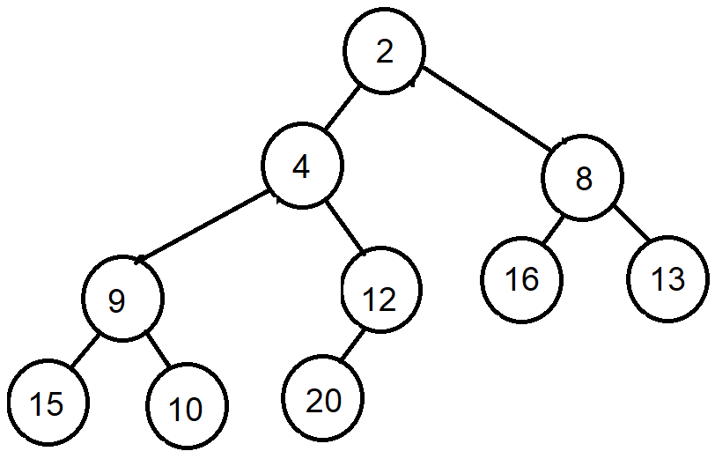

8. Insert 2

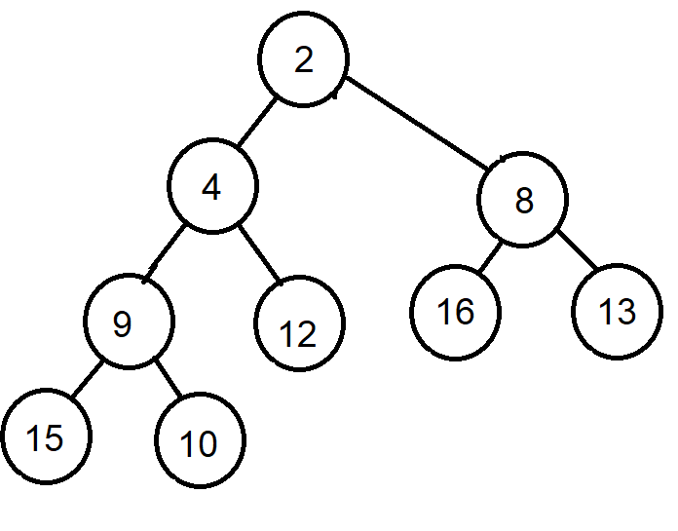

14. Insert 19

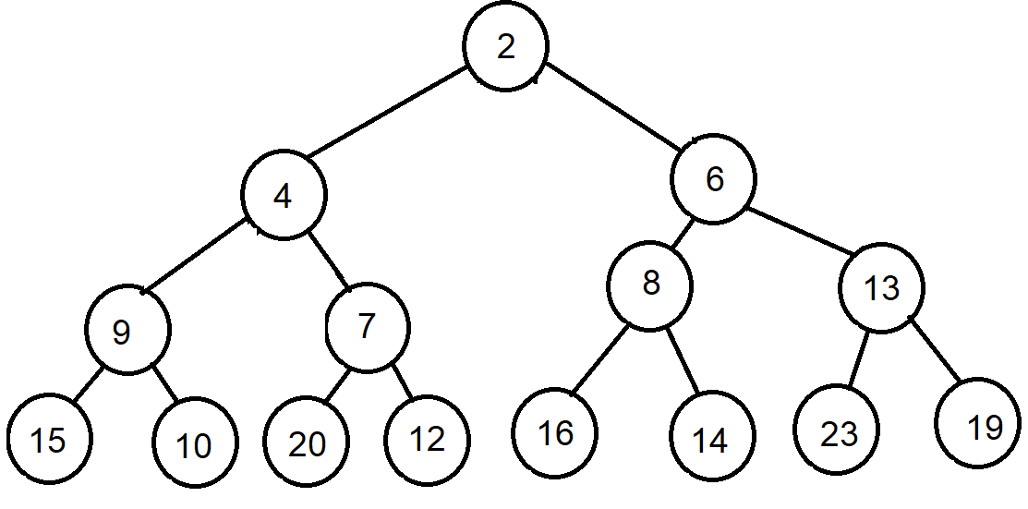

13. Insert 23

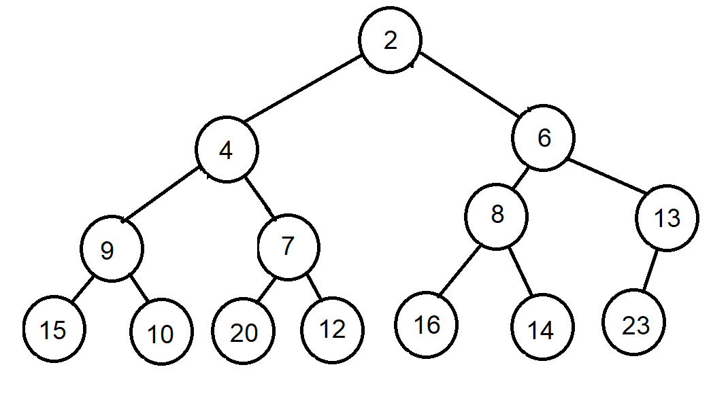

1. Perform removeMin 2 times yields:

Second time and final representation:

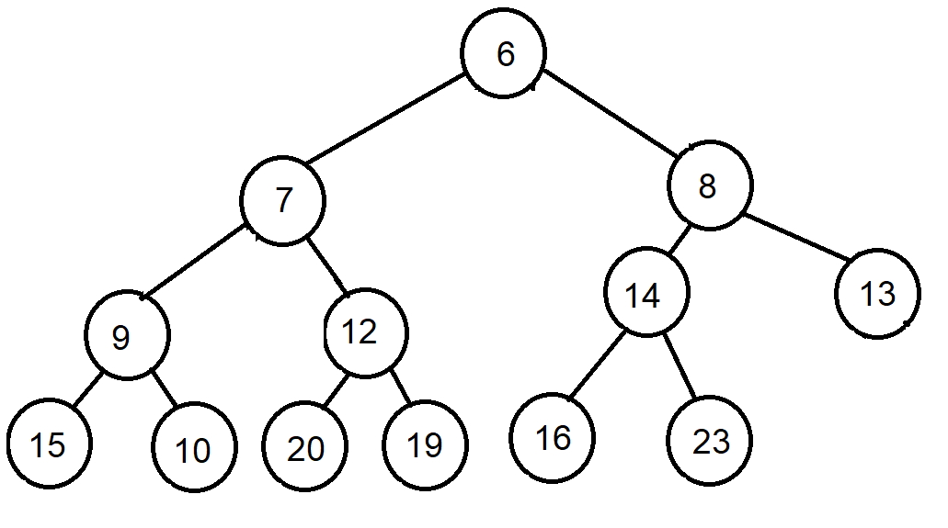

First time

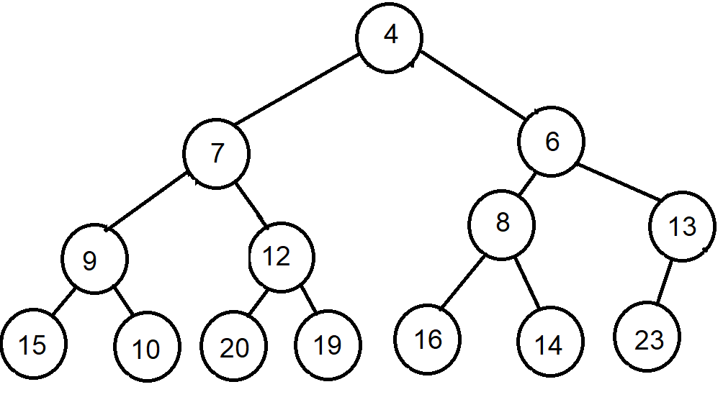

**Question 5:**

1. The following algorithm has a complexity of O(n) where n is the number of nodes the tree contains

**Algorithm** depthOfNode(node)

**Input:** The node you want to compute its depth

**Output**: The depth of that node

// Call the helper funtion

**return** depthOfNode(root, node.data, 0)

/**

* This is a helper function used by

*/

**Algorithm** depthOfNode(node, data, level)

**Input:** ***node*** the Node to compute its depth*,* ***data***the target data*,* ***level***the current level

**Output**: The depth of the node

**if** node = null **then**

**return** 0

**if** node.data = data **then**

**return** level

down ← depthOfNode(node.left, data, level + 1)

**if** down !← 0 **then**

**return** down

down ← depthOfNode(node.right, data, level + 1)

**return** down

1. The following algorithm has a complexity of O(n) where n is the number of node of the tree. Because it is recursive without any loops inside it.

**Algorithm** count-Full-Nodes(t)

**Input:** The node to calculate if its children are full (default is *root of tree*

**Output**: number of full nodes of tree

**if** t = null **or** t.left = null **or** t.right = null **then**

**return** 0

**else**

**return** 1 + count-Full-Nodes(t.left) + count-Full-Nodes(t.right)